EX8-Create a simple cloud web application for student counselling system using any Cloud Service Provider to demonstrate SaaS with the fields of student name, age, address, phone, subjects studied, Year of passing, percentage of marks, domain interest, etc.

PROCEDURE:

Step 1: create a new application named as student counselling

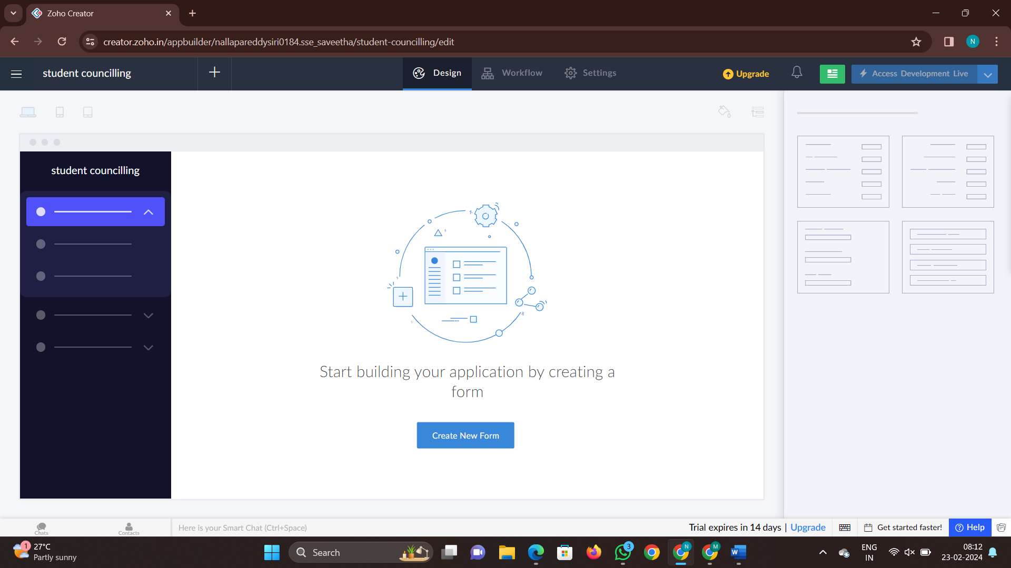

Step 2: create a new form to fill the details

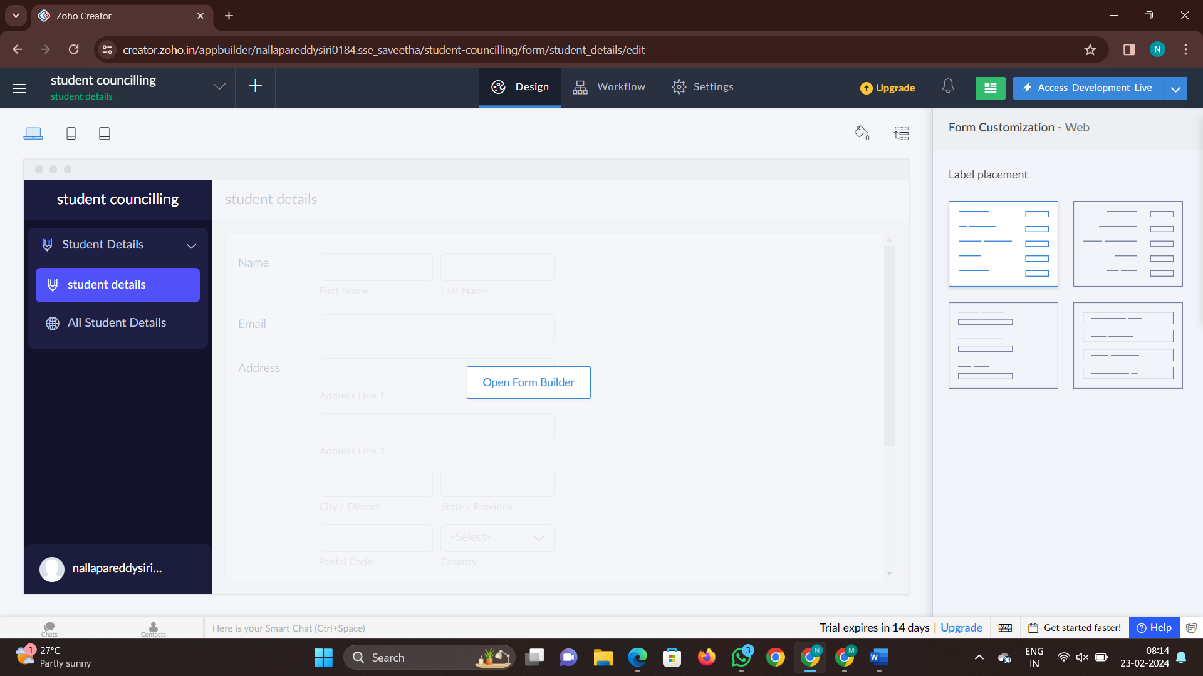

Step 3: Add another form as counselling

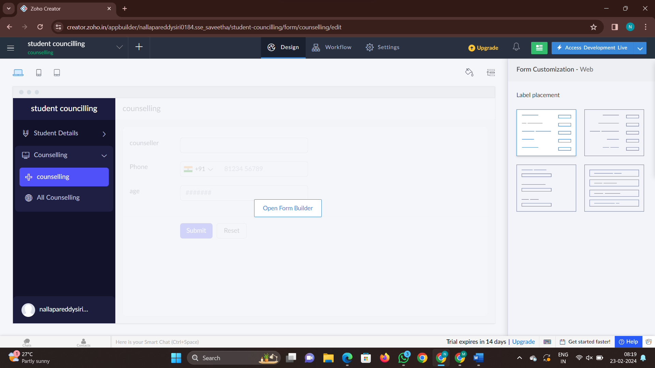

Step 4: add another form in the application

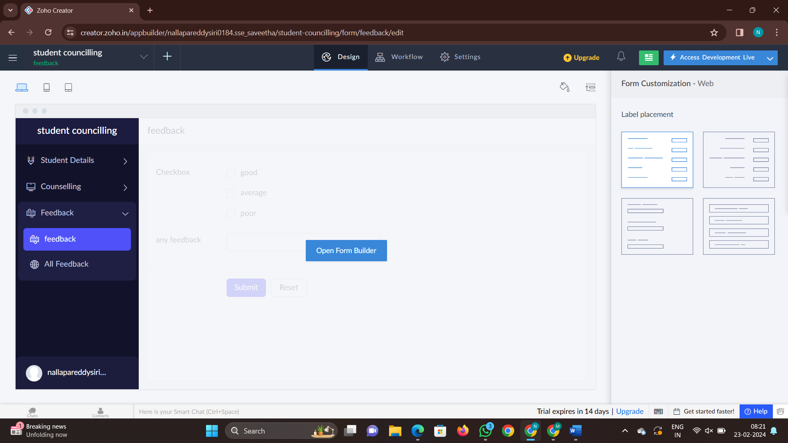Step 5: now click on done and click on access development live and fill details

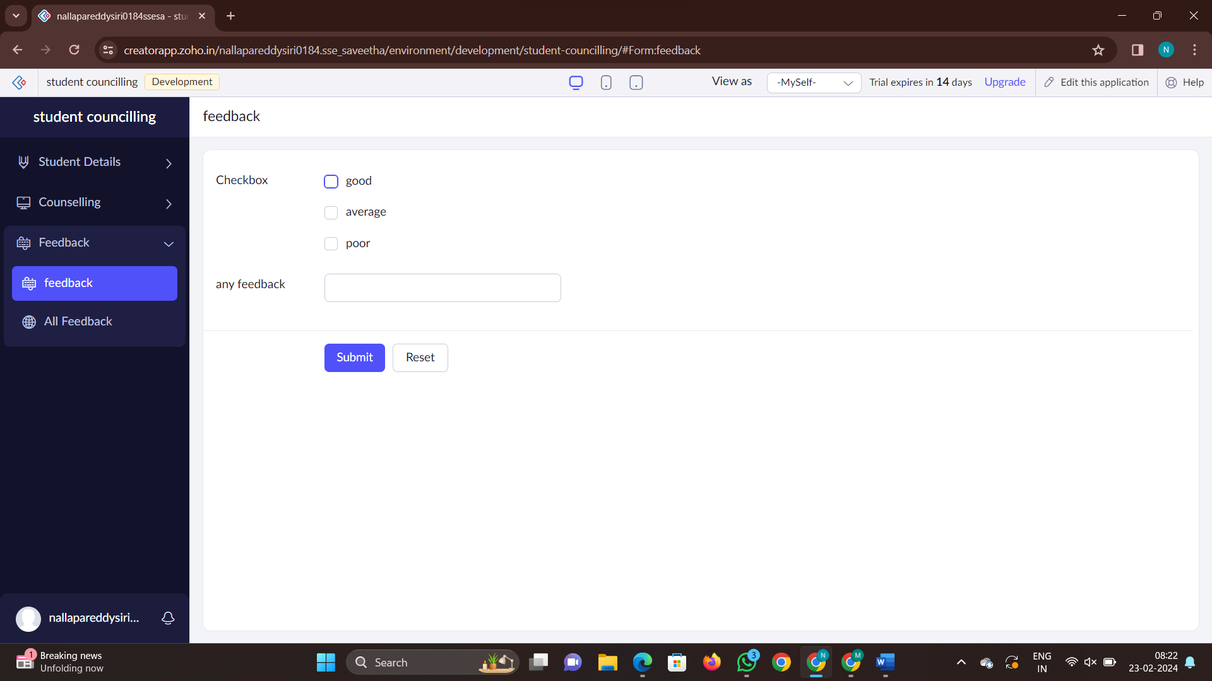

Step 6: check the report of the application for the given forms

